**Problem Statement:**

You work for XYZ Corporation. Their application requires a storage service that can store files and publicly share them if required. Implement S3 for the same.

**Tasks To Be Performed:**

1. Use the created bucket in the previous task to host static websites, upload an index.html file and error.html page.

2. Add a lifecycle rule for the bucket: a. Transition from Standard to Standard-IA in 60 days b. Expiration in 200 days

**Create two file and add in “myawsbucket-module6”**

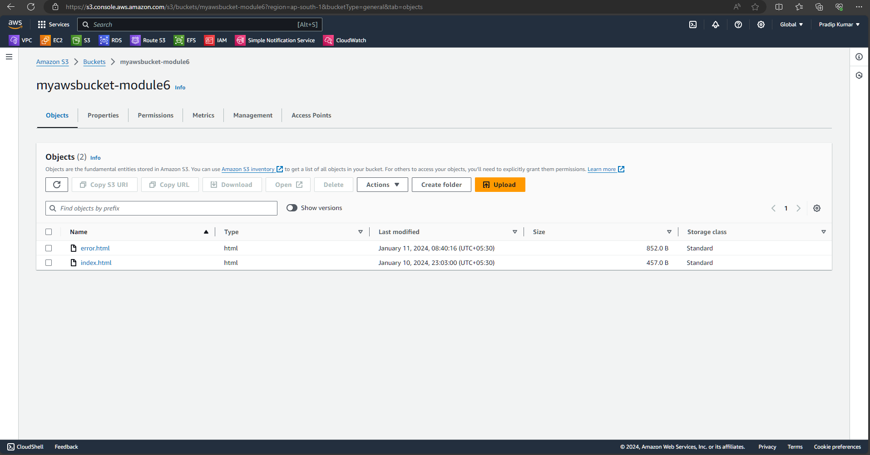

**Go to static website and enable it**

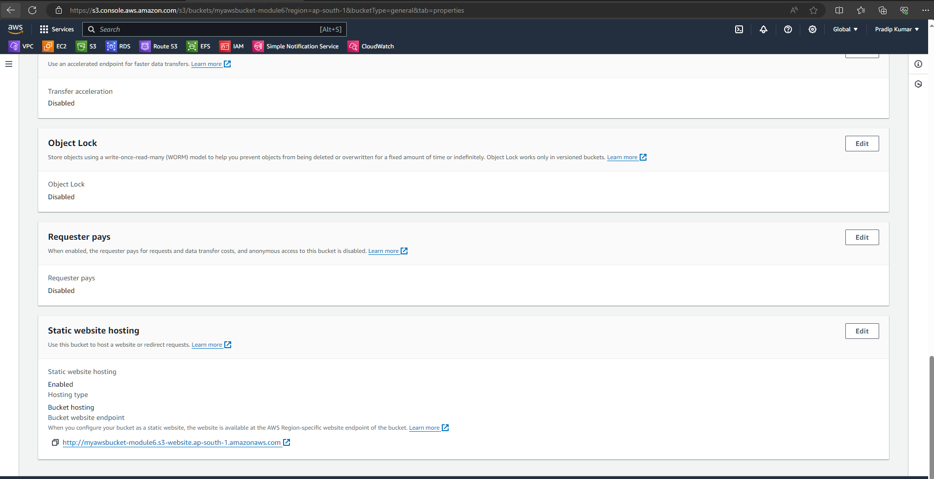

**Also enable that for public**

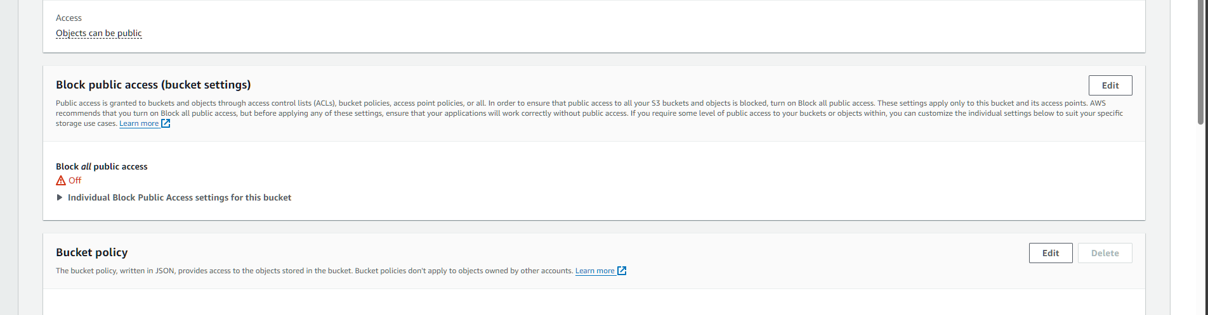

**Also enable Acl**

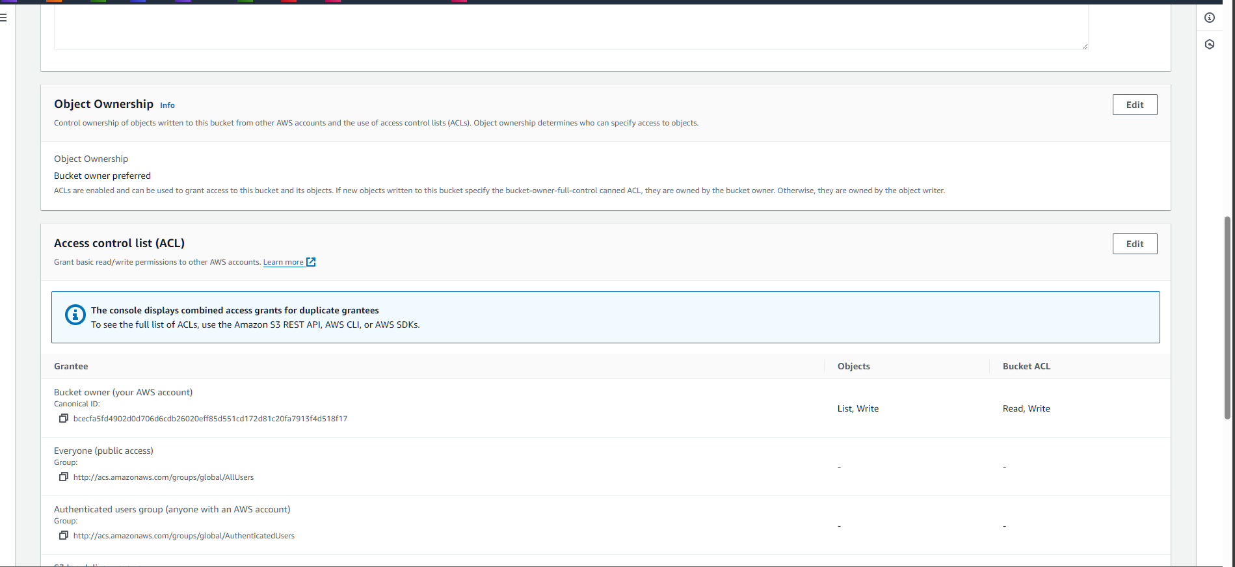

**Make public using ACl**

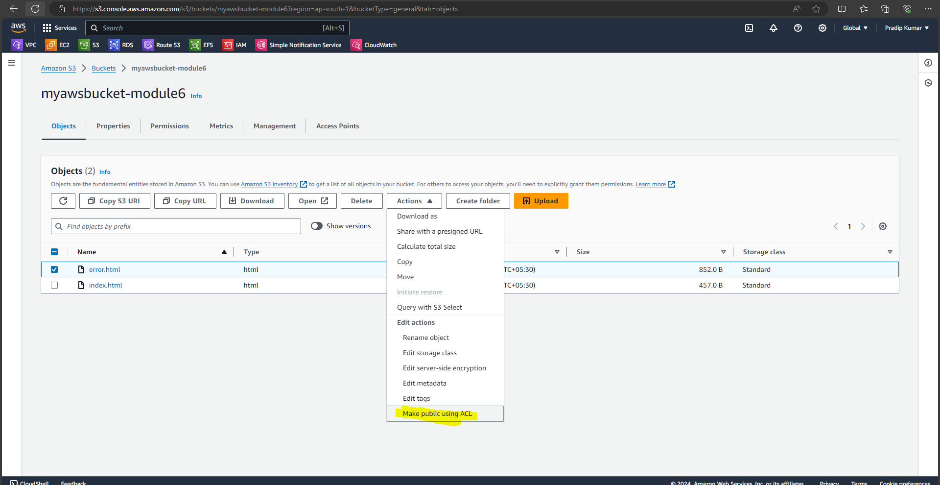

**Now my static website is launch**

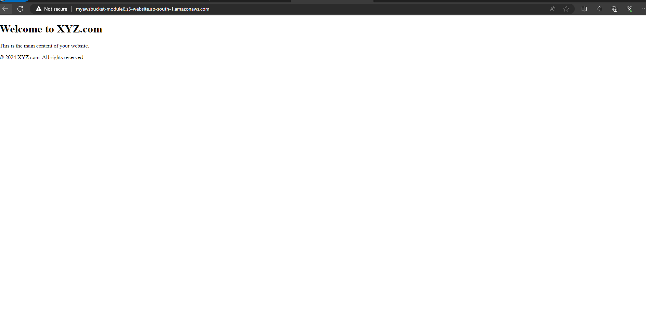

**And this showing wrong url**

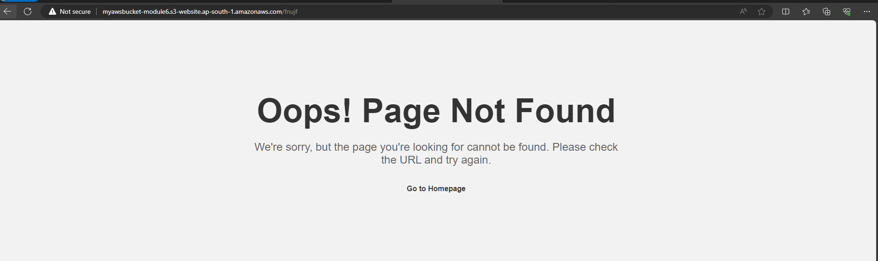

**This is the 2nd situation**

**2. Add a lifecycle rule for the bucket:**

**a. Transition from Standard to Standard-IA in 60 days**

**b. Expiration in 200 days**

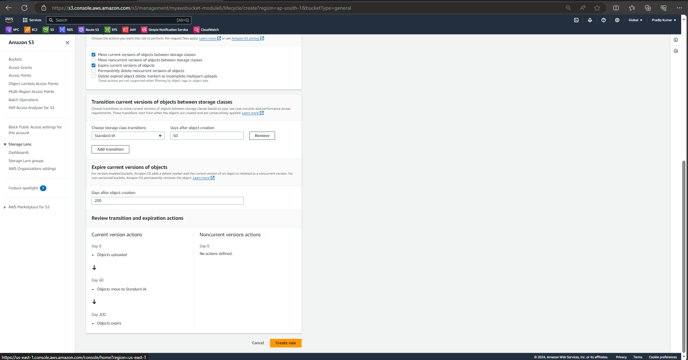

**Now lifecycle has been created**

